VoltWatch: Secure AI Monitoring of Smart Energy Grids
Samuel Howard, Cameron Johnson, April Crockett, & Blaine Swieder

VISION AND GOALS
Modern electric power grids face the ongoing challenge of balancing electricity supply and demand in real time while minimizing cost, protecting consumer privacy, ensuring security of the system, and maintaining reliability. As energy systems become more distributed, with consumers increasingly acting as both users and producers of power, there is a growing need for intelligent, secure, and flexible coordination mechanisms. Our vision is to demonstrate, through simulation, how small, coordinated actions across many consumers can meaningfully support grid stability without requiring intrusive control or detailed personal data.

This project envisions a privacy-preserving, AI-assisted virtual power plant concept in which time-based energy data is analyzed to make automated, low-impact decisions about electricity usage or contribution. By combining data analysis, signal processing, AI-driven decision-making, and cybersecurity principles, the project illustrates how interdisciplinary approaches can address real-world energy challenges in a scalable and consumer-friendly way.
Vision (Fig. 1):
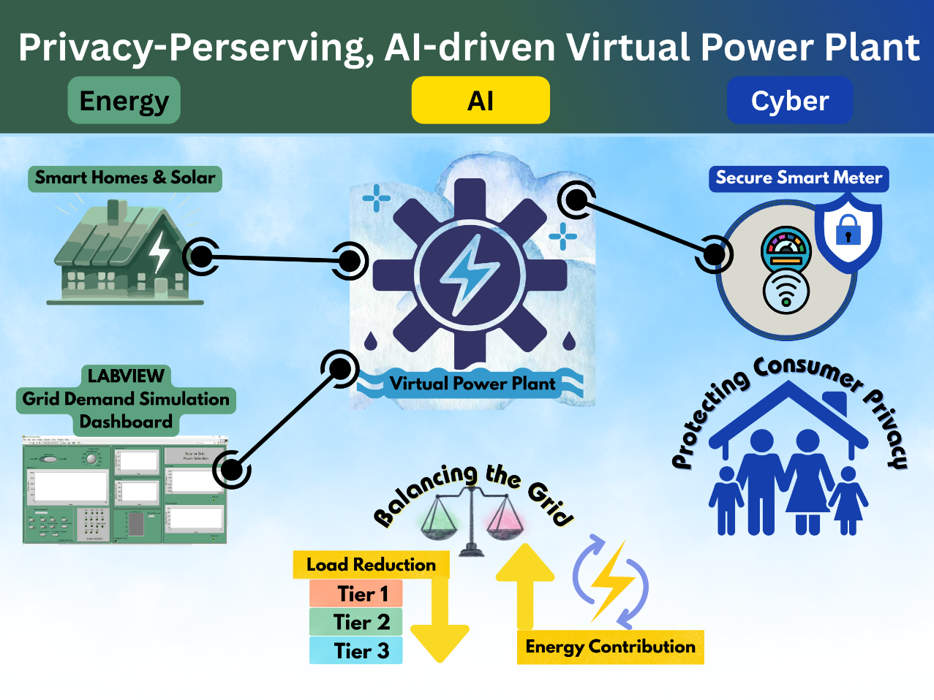
Specific Goals:
The primary goals of this project are to:
- Demonstrate an energy application context by simulating electricity demand and small-scale load adjustments using time-series data representative of grid behavior.
- Demonstrate energy application by using measured time-series energy data representative of grid behavior and applying small-scale load adjustments.
- Implement AI-driven decision logic to adjust load based on system conditions and integrate cybersecurity through privacy-preserving communication.
- Provide intuitive visualization of grid conditions and system responses through live-updating dashboards that reflect how operators might monitor energy systems.
- Showcase interdisciplinary integration by clearly illustrating how AI, cyber, and energy concepts interact within a single coherent system design.

CHALLENGES AND OPPORTUNITIES

Opportunities

We have found the following data sets that we will investigate for our project:

Comprehensive Dataset on Electrical Load Profiles for Energy Community in Ireland in Scientific Data (Sci Data)
Repository Link: https://www.nature.com/articles/s41597-024-03454-2/tables/1.
This dataset (41 .csv files) was collected from 20 residential electricity households within an energy community in Ireland, as part of StoreNet project. The data includes local weather parameters and per household consumption for various aspects such as net generation, net consumption, charging and discharging, and the state of charge of energy storage.

ENERTALK dataset on Scientific Data (Sci Data)
Repository Link: https://www.nature.com/articles/s41597-019-0212-5
This dataset contains both aggregate and per-appliance measurements sampled at 15 Hz from 22 houses in Korea. There are 22 directories, one per house, and each of the houses provided 29 to 122 days of power consumption data.

Individual Household Electric Power Consumption in UC Irvine’s Machine Learning Repository.
Repository link: https://archive.ics.uci.edu/dataset/235/individual+household+electric+power+consumption
This dataset (in .txt format) is an archive containing 2,075,259 measurements of active energy consumed every minute of a house located in Sceaux (7km of Paris, France) between December 2006 and November 2010 (47 months).

Challenges

Modern electric grids face increasing complexity as distributed energy resources such as solar and residential storage expand alongside rising electricity depend on large-scale data center development. Maintaining real-time supply-demand balance challenges traditional centralized control models, prompting utilities such as TVA to extend coal plant operations to meet increasing load. At the same time, smart grid monitoring introduces privacy and cybersecurity risks, as high-resolution energy consumption data can reveal sensitive household behavioral patterns. AI systems are also vulnerable to manipulation, inference attacks, and data integrity breaches (Trivedi et al., 2024, Zhang et al., 2026).

Our project will address these documented challenges by modeling an AI-assisted virtual power plant that operates on aggregated time-series data rather than individual household profiles. By integrating explainable AI decision logic with privacy-preserving validation mechanisms, the project demonstrates how grid coordination, cybersecurity safeguards, and consumer privacy can be jointly addressed within a unified system design

[1] R. Trivedi, M. Bahloul, A. Saif, S. Patra, and S. Khadem, “Comprehensive Dataset on Electrical Load Profiles for Energy Community in Ireland,” Sci Data, vol. 11, no. 1, Dec. 2024, doi: 10.1038/s41597-024-03454-2.
[2] Zhang Zikai, Rath Suman, Xu Jiahao, and Xiao Tingsong, “Federated Learning for Smart Grid: A Survey on Applications and Potential Vulnerabilities,” ACM Transactions on Cyber-Physical Systems, vol. 10, no. 1, pp. 1–26, Jan. 2026, doi: 10.1145/3760788.

APPROACH AND METHODOLOGY
In this project we will design and implement a simulated, privacy-preserving smart grid monitoring system with data analysis, signal processing, AI-driven decision-making, and cybersecurity validation mechanisms. The system will operate on time-series energy data to demonstrate how coordinated, low-impact load adjustments can support grid stability.

The system will be developed modularly, with clear separation between data ingestion, AI analysis, cybersecurity validation, and visualization components. This approach allows each technical domain (AI, Cyber, Energy) to be explored independently while still contributing to a unified system architecture. We will use an Agile development process with iterative testing.

Team Roles and Responsibilities:
- Samuel Howard: Lead AI and Cyber development, including decision logic design, demand analysis, threshold-based action modeling, and cybersecurity modeling.
- Cameron Johnson: Lead Energy data procurement and preprocessing, data analysis, signal processing, and evaluation of system-level energy impacts.
- Blaine Swieder: Lead System Integration and architectural coordination and ensuring interaction across AI, cyber, and energy components.
- April Crockett: Lead project documentation, communication, and presentation materials, visualization design, creation of teaching materials for bootcamp. Serve as wildcard, aiding teammates where needed.

Detailed Tasks and Timeline:
- Task 1: Project Proposal & Timeline (timeline: 1 week)
Preparing project proposal, timeline, expected milestones, and project presentation
- Task 2: Data Acquisition and Preprocessing (timeline: 2 weeks)
April & Cameron will find energy-related time-series datasets and will clean, normalize, and prepare for data analysis. Cameron will establish baseline demand profiles.
- Task 3: Energy Signal Processing Development (timeline: 1-3 weeks)
Cameron will create a visualization to show demand behavior and small-scale load adjustments.
- Task 4: AI Decision Logic Implementation (timeline: 3 weeks)
Samuel and Blaine will implement AI-based decision rules to evaluate grid conditions and aid in load shaping based on aggregated demand data. detect peak conditions and recommend load changes based on aggregated demand data. To do this, the AI component will analyze recent and historical energy demand trends, detect high-load or peak-risk periods, determine when load reduction or energy contribution actions should be recommended, and quantify the magnitude of suggested actions while minimizing customer disruption. The AI logic will operate on aggregated data rather than individual household profiles to reinforce privacy-preserving design principles.
- Task 5: Cybersecurity and Validation Modeling (timeline: 2 weeks)
Samuel and Blaine will add privacy-preserving validation mechanisms and integrity checks to simulate secure system interactions. Cyber elements include validation checks confirming system state changes without revealing user-specific behavior, simple integrity verification to ensure data has not been altered during processing, and conceptual modeling of secure communication channels between system components.
- Task 6: Mid Semester Milestone Presentation (timeline: 1 week)
April will create the mid semester milestone presentation materials and the group will finalize.
- Task 6: System Integration and Visualization (timeline: 2-3 weeks)
Blaine and April will integrate into a unified system with a live-updating dashboard for monitoring system behavior. April will design the visualization layer, which will display real-time and historical energy demand trends, AI-triggered decision points, and aggregate load adjustments.
- Task 7: Testing, Evaluation, and Refinement (timeline: 1 week)
The whole team will test the full system under multiple simulated demand scenarios to evaluate performance, stability, and clarity of results.
- Task 8: Preparing Bootcamp Presentation & Activities (timeline: 1 week)
April will create presentation materials and activities for an undergraduate bootcamp.

Project Timeline and Expected Milestones
 | February |  |  |  | March |  |  |  | April
Task | Feb 1-7 | Feb 8-14 | Feb 15-21 | Feb 22-28 | Mar 1-7 | Mar 8-14 | Mar 15-21 | Mar 22-28 | Mar 29-Apr 4 | Apr 5-11 | Apr 12-18 | Apr 19-25
Form Teams | all
Project Proposal & Timeline |  | April | all
Project Timeline & Expected Milestones |  | April | all
Project Presentation of Proposal & Timelline |  |  | all
Data Acquisition and Preprocessing |  |  | Cameron | Cameron
Energy Signal Processing Development |  |  |  | Cameron | Cameron | Cameron
AI Decision Logic Implementation |  |  |  | Samuel | Samuel | Samuel + Blaine
Cybersecurity and Validation Modeling |  |  |  |  | Blaine | Blaine + Samuel
Mid Semester Milestone |  |  |  |  |  | April | all
Visualization |  |  |  |  | April | April | April
System Integration |  |  |  |  |  |  | Blaine | all
Testing, Evaluation, and Refinement |  |  |  |  |  |  |  | all
Preparing Bootcamp Presentation & Activities |  |  |  |  |  |  |  |  | April (draft) | all (final)
Final Presentation |  |  |  |  |  |  |  |  |  | April (draft) | all (final) | all

INTELLECTUAL MERIT
Our project contributes to the fields of Artificial Intelligence, Cybersecurity, and Energy Systems by demonstrating how these domains can be meaningfully integrated within a single, coherent system design. The intellectual merit of this work is in its unique interdisciplinary approach and its focus on practical, explainable mechanisms.

From an energy systems perspective, the project illustrates how small, distributed load adjustments can be coordinated to support grid stability using time-series demand data. The simulation highlights the role of consumer-side flexibility and virtual power plant concepts in modern energy management, offering insight into non-intrusive strategies for balancing supply and demand.

In the artificial intelligence domain, the project demonstrates how lightweight, interpretable AI techniques can be effectively applied to real-world infrastructure problems. By emphasizing rule-based and trend-aware decision logic rather than complex black-box models, the system prioritizes transparency, explainability, and appropriateness for safety-critical domains such as energy systems.

From a cybersecurity standpoint, the project reinforces the importance of privacy-preserving and integrity-focused design in cyber-physical systems. The modeling of anonymized validation and secure communication workflows illustrates how system-wide coordination can occur without exposing sensitive individual data, addressing a key challenge in smart grid deployments.

Collectively, the project serves as a proof-of-concept that interdisciplinary design principles can be applied in a scalable and educationally meaningful way, offering a framework that could be extended in future research or coursework.

BROADER IMPACTS
The broader impacts of this project extend beyond technical contributions by addressing societal concerns related to energy reliability, data privacy, and public trust in automated systems. By demonstrating privacy-preserving approaches to energy coordination, the project promotes consumer confidence in smart grid technologies. This is particularly important as concerns about surveillance, data misuse, and loss of autonomy can hinder public acceptance of intelligent infrastructure. The project will demonstrate that grid support mechanisms do not require invasive monitoring or control by utility providers.

The project also contributes to energy sustainability and resilience by highlighting how coordinated, low-impact actions across many users can reduce peak demand and improve grid stability. Such approaches support more efficient use of existing infrastructure and can complement the integration of distributed and centralized renewable energy sources.

From an educational and workforce development perspective, the project provides a clear, accessible example of how AI, cybersecurity, and energy concepts intersect in practice. This intersection makes it valuable as a teaching tool for students entering interdisciplinary fields such as cyber-physical systems, smart infrastructure, and applied AI. The modular design and visualization components further enhance its usability in classroom or demonstration settings.

Finally, the project encourages responsible AI adoption by modeling systems that are aligned with societal values. By emphasizing privacy and minimal intrusion, the project supports broader efforts to develop trustworthy intelligent systems that serve the public good.

- PROJECT PERSONNEL and EXPERTISE
- Samuel Howard – B.S. Computer Science, currently working on M.S. Computer Science focusing on AI/Cyber
- Cameron Johnson – B.S. Mechanical Engineering, currently working on M.S. Mechanical Engineering focusing on Data Acquisition
- April Crockett – B.S. Computer Science, M.S. Computer Science, currently working on PhD Computer Science, focusing on Computer Science Education
- Blaine Swieder – B.S. Computer Science & Mathematics, currently working on M.S. Electrical & Computer Engineering and M.S. Computer Science focusing on AI / Systems
- PROJECT RISKS AND ALTERNATIVE PLANS
- Publicly available energy datasets may be incomplete or too noisy to adequately represent grid behavior. This could limit the fidelity of the energy modeling component. If real-world datasets prove insufficient, the project will supplement or replace them with synthetically generated time-series data that reflects typical demand patterns (e.g., daily peaks, seasonal variation). Synthetic data will be clearly labeled and designed to preserve realism while enabling controlled experimentation.
- The AI component may be either too simplistic to demonstrate meaningful system behavior or too complex to remain interpretable and aligned with project goals. The project will adopt an iterative AI design approach, starting with a consumption predictor and some form of ruleset and then progressively adding trend-based or predictive elements only if they improve clarity and usefulness. If more advanced methods do not add clear value, the project will prioritize explainability over complexity.
- Developing a live-updating visualization may require more time or technical effort than anticipated. If real-time dashboards are not feasible, the project will use static or step-based visualizations generated from simulation outputs. These visualizations will still clearly demonstrate system behavior, decision points, and outcomes.
- Limited project duration or overlapping responsibilities may affect progress across tasks. Tasks will be prioritized to ensure core project objectives are met first, including energy simulation and AI decision logic. Optional or enhancement features will be deferred if necessary, and responsibilities will be rebalanced within the team to maintain progress.

